**Question Creator Form Documentation**

This document is a documentation of the Question Creator windows form application, it will be sectioned off into three sections, **End user documentation**, **Administrator documentation**, **Developer documentation**.

**End user documentation**:

This section will walk you through the different forms, and what each form aims to accomplish.

**Landing form**:

The landing form is where the user can see all the questions and interact with them, it shows the user a list of questions that are present in the database as well as them being updated with the database every ten seconds.

Landing form controls:

* List: lists all the questions from the database, showing off their text, type and their order, and the list column headers can be clicked and that will allow the user to sort the questions based on the column header that was clicked.
* Refresh button: refreshes the data directly from the database, if successful a message will show at the bottom of the list indicating that a refresh happened and the data is up to date with the database.
* Add button: Launches the questions form which allows the user to add a new question.
* Edit button: Launches the questions form with the currently selected question in the list and allows the user to edit that specific question. (This button is only activated when a question is selected in the list)
* Remove button: launches a message to prompt the user for consent to remove the currently selected question in the list. (This button is only activated when a question is selected in the list
* Settings button: Launches the settings form
* Exit button: Closes the application

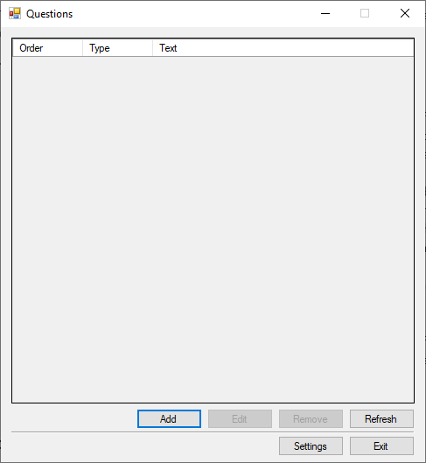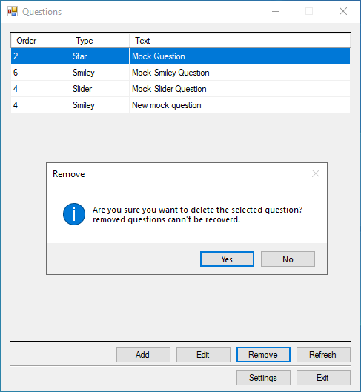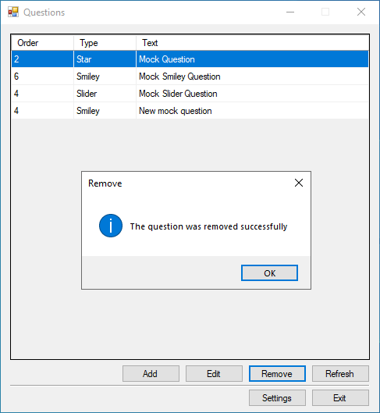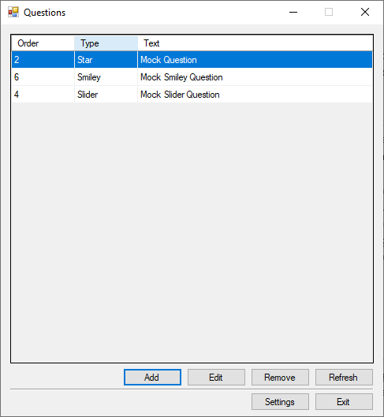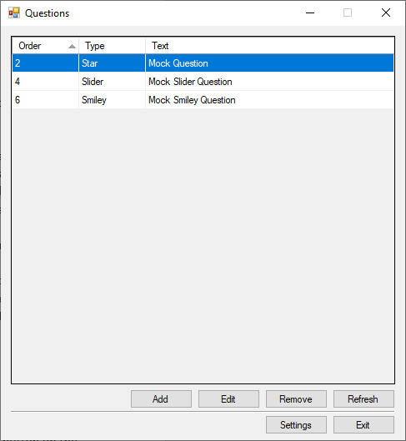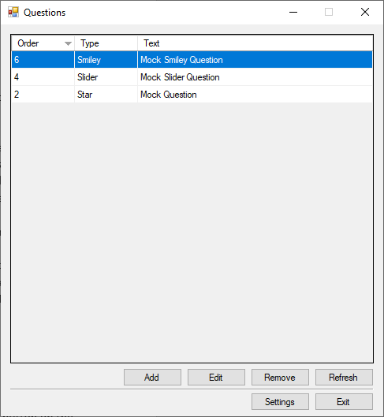

**Question form**:

The question form lets the user either add a new question or edit a new question, editing a question is accessed through pressing the Edit button on the landing form, while adding a new question is accessed through pressing the Add button in the landing form. (Adding or updating questions will reflect automatically to the database and to the landing form list)

Question form controls:

* Question type dropdown: this is a dropdown list containing the possible types of the questions that can be chosen from, choosing different types will change the extra data that the new question has. (disabled when editing a question)
* Question text input field: an input field that allows the user to edit/add the question text, has a max character count of 250.
* Question order numeric box: a numeric box that lets the user change the value of the new/old question order value.
* Update/Add button: this lets the user finish the action of creating/editing a question, then launches a message box that contains the outcome of the Adding/Updating operation, whether It’s a success or not.
* Cancel button: lets the user exit the question form and return to the landing form.

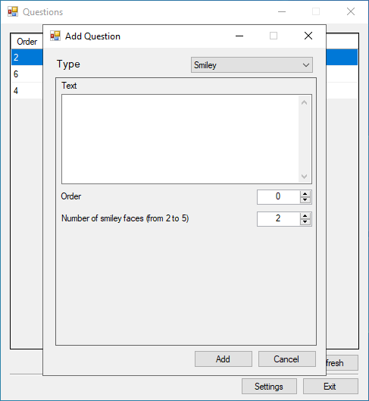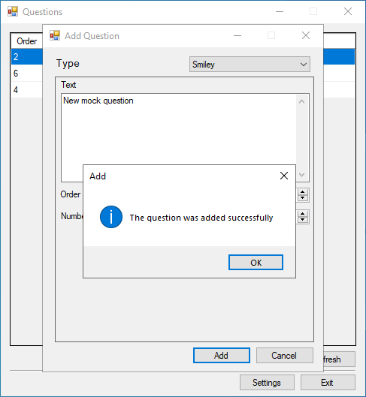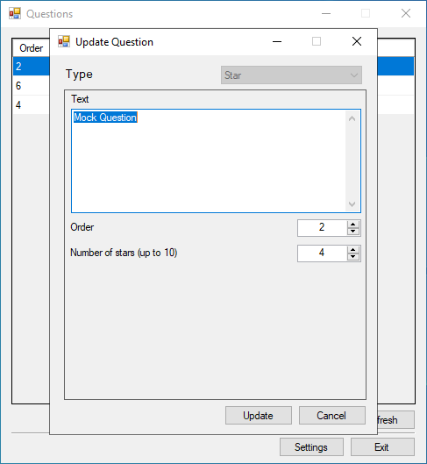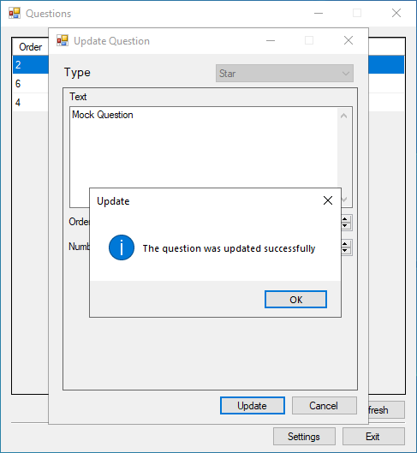

**Settings form**:

The settings form is where the user can change different settings options, such as the language and the connection type and info, as well as being able to test out new connections.

**Settings form** controls:

* Language dropdown menu: The language dropdown menu lets the user choose the language they want to use, the two options are Arabic and English, whenever a user chooses a language to use a message box letting the user know the result of selecting that language and then automatically restarting the application with the newly selected language.
* Connection settings input fields: These are a group of input fields that let the user control the connection settings to the database, on top of that a test connection button that allows the user to test out connection settings before actually saving them and using them.

